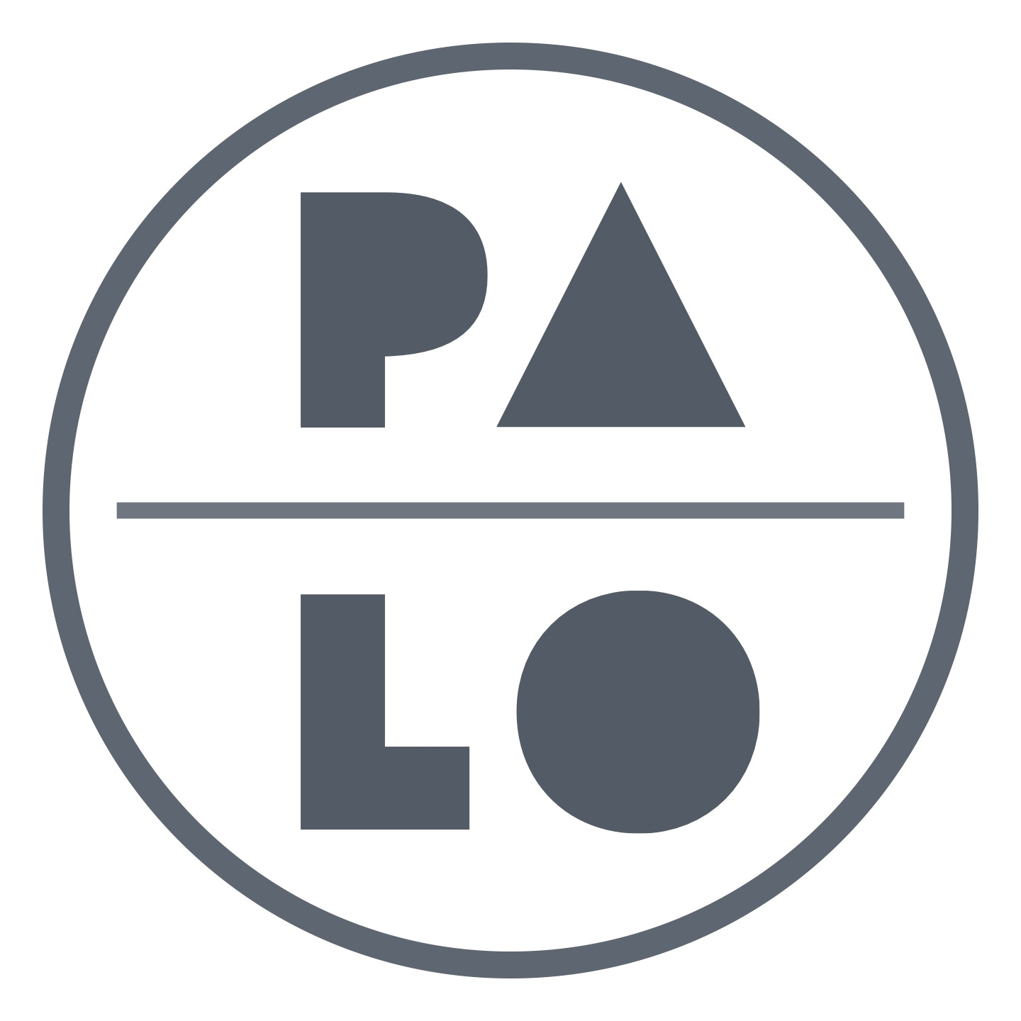
Lee Jaffe

Artist Bio

Lee Jaffe first came to international prominence in the 1980s with his large scale, multi-media historical assemblage works. His chosen themes are controversial and visionary, an exploration of the world's urgently changing internal circumstances. His genius lies in his quest to overcome the dogma of any single classification, treating topics in all fields including the exploitation of the black performer in America, the cruelty of the fur industry, the relationship of the Native American to his environment, the ambiguity of America's traitors. Lee Jaffe combs communal history for universal deficiencies, searching not to reconcile, but to bring light from a different direction. Lee Jaffe's works are especially memorable for their unique use of materials, often combining poetry, sculpture, sound, and found objects with media and technology. Many of his pieces are interactive, crossing the line that divides a performer from his audience. Prior to this period of art production Lee Jaffe played a unique role in the history and early international recognition of Reggae music and culture. Lee Jaffe lived with Bob Marley in Jamaica for three years and was a member of The Wailers playing harmonica. He later produced Peter Tosh's "Legalize It" album and shot the iconographic album cover. Most recently, Lee Jaffe's work has focused on his experiences with Reggae culture, producing a major monograph on Bob Marley and Jamaica, and a deluxe photo edition documenting these same subjects. In addition to the resumption of his own studio art production, Lee Jaffe has recently produced a portfolio of his own photographs documenting the artist Jean-Michel Basquiat at work.

Exhibition History
2006
M B Fine Art, Los Angeles, California

1994
Ikon Gallery, Birmingham, England
Irish Museum of Modern Art, Dublin Ireland

1993
Institute of Contemporary Art, Amsterdam, Holland

1992
Moderna Museet, Stockholm, Sweden

1991
Ace Gallery, Los Angeles, California
Edward Thorden Gallery, Goteborg, Sweden

1990
Marc Jancou Gallery, Zurich, Switzerland

1989
Kaj Forsblom Gallery, Helsinki, Finland
Galerie Grafiart, Turku, Finland
Georges Lavrov Galerie, Paris France

1988
L.A. Louver Gallery, Los Angeles, California
L.A. Louver Gallery, Los Angeles, California
Edward Thorden Gallery, Gotenborg, Sweden

1986
Anders Tornberg Gallery, Lund, Sweden 1986
Burnett Miller Gallery, Los Angeles, California
Nicola Jacobs Gallery, London, England

1985
Lawrence Oliver Gallery, Philidelphia, Pennsylvania
Anders Tornberg Gallery, Lund Sweden
Bette Stoler Gallery, New York, New York

1983
Bonnier Gallery, New York, New York
Main Gallery, Fine Arts Center, University of Rhode Island, Kingston Rhode Island

